Name Sorter App

**Overview:**

The Name Sorter console application reads a list of names from an input file, sorts them by last name and given names, and outputs the sorted list to both the console and a new file(sorted-names-list.txt).

**Usage:**

To use the Name Sorter application, follow these steps:

* Compile the application using the .NET Core SDK.
* Run the compiled executable with the path to the input file as an argument

Example usage:



**Input:**

The input file should contain a list of names, with each name on a separate line. Names can consist of one to three given names followed by a last name.

Example input file (G:\unsorted-names-list.txt):



**Output:**

The application will print the sorted list of names to the console and write them to a new file called sorted-names-list.txt in the working directory.

Example output:

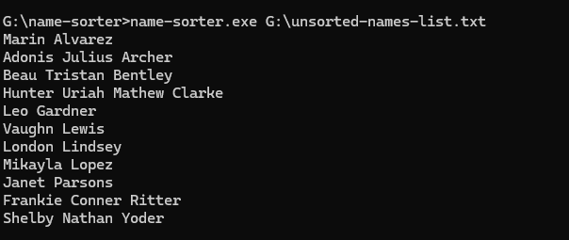

**Dependencies:**

* .NET Core 3.1 or higher

**Testing:**

The application includes unit tests for the NameParser and NameSorter classes. To run the tests, use a unit testing framework such as NUnit.